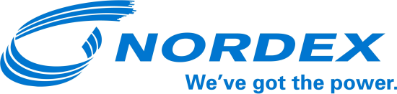

PRESS RELEASE

Six new orders for the Nordex Group in France

Manufacturer sells turbines with total capacity of 93.3 MW

Hamburg, 28 October 2016. So far this autumn, Nordex has obtained six new orders for wind farm projects in France. Altogether, 38 turbines with a combined capacity of 93.3 MW have been sold to different customers: 17 N117/2400s, 15 N100/2500s and six N90/2500s. Nordex will provide service for all these machines after installation on the basis of a Premium Service contract for periods of 10 or 15 years.

They will be delivered and installed in 2017, and in the case of three of the wind farms, the manufacturer was involved in developing the project via its Nordex Development division. It is also responsible for the turnkey installation of the turbines, including the transformer stations and infrastructure.

Since entering the market in 1998, the Nordex Group has installed a total of 1.5 GW in France, and last year achieved a cumulated market share of 14 percent. Almost half of the projects were in partnership with Nordex Development.

The Nordex Group - a profile
The group has installed around 20 GW of wind energy capacity in over 25 markets. In 2015, Nordex and Acciona Windpower generated combined revenues of EUR 3.4 billion. The company currently employs a workforce of more than 5,000, and its joint manufacturing capacity includes factories in Germany, Spain, Brazil, the United States and India. The product portfolio focuses on onshore turbines in the 1.5 to 3.6 MW class, which are tailor-made for the market requirements in developed and emerging markets.

For more information, please contact:
Nordex SE
Felix Losada
Phone: 040 / 300 30 – 1000
Flosada@nordex-online.com

