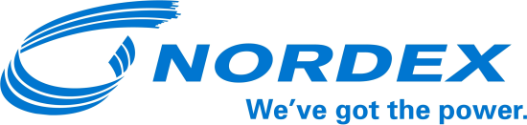

Press release

Tail wind for Nordex in Germany

Hamburg, 14 October 2016. In September, Nordex was awarded six new contracts with a combined value of around EUR 64 million in its domestic market, bringing total new business in this region to over EUR 740 million in the year to date.

Last month, Nordex customers ordered 17 multi-MW turbines. The orders were dominated by low and medium-wind (IEC 2 and 3) products, in which Nordex particularly specialises in Germany. “I consider the growing demand for our Delta series to be a good sign. In this way, we are able to continue the success of our bestseller, the N117/2400,” says Jörg Hempel, who is in charge of Nordex’s German business. The Delta series now accounts for more than 60 percent of the order intake.

The largest single project in September was the “Hengeler-Wendfeld” wind farm. This citizen-financed wind farm is composed of seven N131/3300 turbines installed on 134-meter high hybrid towers, thus making optimum use of the wind in the Münsterland region.

About Nordex
The Group has installed wind power capacity of around 20 GW in over 25 markets. In 2015, Nordex and Acciona Windpower recorded combined sales of EUR 3.4 billion. The Company currently has roughly 5,000 employees. The production network comprises plants in Germany, Spain, Brazil, the United States and India. The product range primarily concentrates on onshore turbines in the 1.5 - 3.6 MW class addressing the requirements of developed as well as emerging markets.

For more information, please contact:
Nordex SE
Felix Losada
Telephone + 49 40 300 30 – 1000

