Press Release 18.05.2017

SeaRenergy adds CMID to its services

SeaRenergy further extends its services in the offshore wind business and is now offering CMID´s (Common Marine Inspection Documents ). CMID´s will be carried out by our inhouse Accredited Vessel Inspector (AVI).

CMID provides a standard format for the inspection of offshore vessels. Its use helps to promote safety and efficiency. The aim of the CMID is to provide a measure for vessel safety and environmental assurance, safety of personnel, and protection of the environment.
For the vessel operator a CMID may help to reduce the number of third party repeat inspections on individual vessels by providing a consistent, transferrable format. This format equally meets the requirements of the vessel operator and the client.

SeaRenergy is an independent provider of comprehensive services for all offshore wind industry stakeholders. We are involved in the whole value chain from T&I concept design and installation to operations and maintenance. We offer consulting and engineering services, as well as offshore marine services (e.g. transport, logistics, construction site safety) and the full range of offshore professionals .

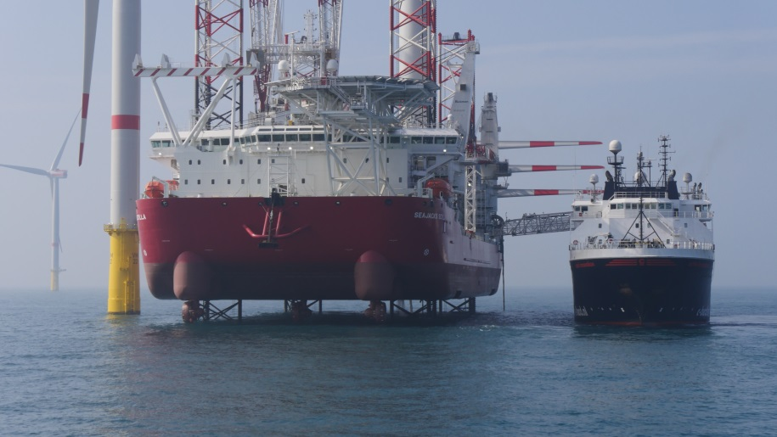

Contact:

SeaRenergy Offshore Holding GmbH & Cie. KG
Carlina Dieselhorst
+49 40 808 172 139
c.dieselhorst@searenergy.com

