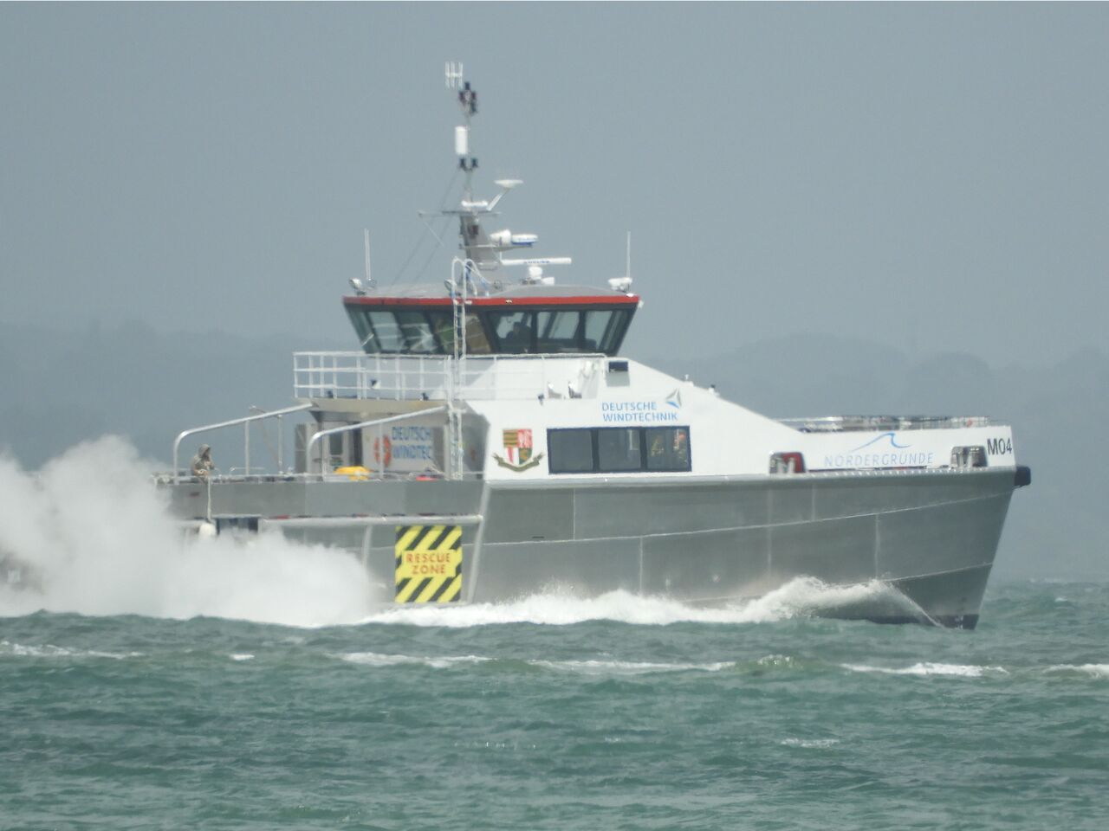
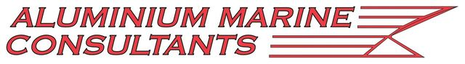

Mainprize Offshore WFSV at Seawork
The fruit of a ground-breaking WFSV build partnership between Aluminium Marine Consultants (AMC) and Mainprize Offshore Ltd will be on the quayside (berth VB32) at Seawork International this year.
With unique features such as a dedicated three-point mooring system, fuel transfer system and a draft of only 1.4m, the 23m WFSV MO4 has been designed and built to operate in shallow water conditions and take windfarm service vessels to the next level.
“We chose AMC because of its flexibility and the company’s attention to detail and workmanship, coupled with its willingness to meet the tight deadlines the client required,” said Bob Mainprize, manging director, Mainprize Offshore Ltd.
He pointed out that from the keel being laid up to the handover, the build time for the MO4 has been less than nine months. This has meant a build time saving of almost four months reducing build finance cost and risk.
“This means that MO4 will start to pay back four months earlier than any other builder can offer,” Mr Mainprize added.
MO4 is fitted with twin Caterpillar C32 diesel engines driving fixed pitch propellers that gives the vessel a service speed of 26 knots, even when fully loaded.
The vessel has been designed with huge amounts of deck space both fore and aft and has been designed for shallow water work with a 1.4m draft. It can carry up to 30,000 litres of fuel or 20,000 litres of water and has provision for 4 x 20' containers and 30t of deck cargo.
Mainprize’s MO4 will be put to work straight away in the German windfarm sector on an eight-year contract with Deutsche Windtechnik on the Nordergründe windfarm. There it will perform crew transfer, cargo and equipment duties out of the port of Hooksiel.
Mainprize has built up a four-and-a-half-year relationship with Deutsche Windtechnik working on Vattenfall’s DanTysk and Butendiek windfarms, where it has more than upheld its proven track record in achieving reduced weather down time and almost zero hours’ maintenance and breakdown rates, resulting in increased cost efficiencies for the windfarm operator.
<ENDS>
Word count: 385

Notes for Editors
About Aluminium Marine Consultants
Aluminium Marine Consultants is one of the leading Aluminium Boat Builders based in the UK, specialising in the construction of aluminium OSV, Workboat and Hovercraft. Having built over 40 vessels with a team of qualified Tradesmen. With a skilled team that can be mobilised for Emergency repair services. www.aluminium-boats.com

For more information contact:
Rob Stewart,
Aluminium Marine Consultants,
St Catherine's Trinity Wharf,
Trinity Road,
East Cowes, IOW,
PO32 6RF,
UK
T: +44 (0) 1983 298736
E: rob@aluminium-boats.com
www.aluminium-boats.com

About Mainprize Offshore Limited
This family company was formed in 1979 and has operated in the North Sea for over thirty years. During this time the company has gained extensive experience in the offshore oil, gas and renewable industry. Its main areas of operations are support work including cables - pipeline guard, chase work, pre lay grapnel operations, grab sampling and camera work, seabed surveys, impact surveys, traffic monitoring and TV work.

For more information contact:
Bob Mainprize,
Mainprize Offshore Limited,
Unit 15 Manor Court,
Manor Garth,
Eastfield,
Scarborough,
North Yorkshire,
YO11 3TU,
UK
T: +44 (0)1723 586022
E: info@mainprizeoffshore.co.uk
www.mainprizeoffshore.co.uk

For more press information and images, please contact:
Sue Stevens
Sue Stevens Media Ltd
E: suestevens@suestevensmedia.co.uk
www.suestevensmedia.co.uk
T: +44 (0) 23 8029 2992
M: 07766 163663

