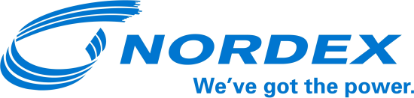

PRESS RELEASE

Nordex with a hattrick in France

Hamburg, 15 June 2017. The Nordex Group has been awarded three new contracts covering a total capacity of 36 megawatts in France. Different project developers and power station operators have placed orders for the installation of a total of 13 N131/3000, N117/3000 and N117/2400 turbines. Work on the wind farms is to commence this year.

Nordex will be installing its N131/3000 turbine in France for the first time. With a rotor diameter of 131 metres, it will be the largest turbine installed in France to date. The turbine will be able to generate large energy yields even in light wind regions and fits perfectly to the site conditions thanks to its very low acoustic output levels.

With an installed capacity of over 1.7 GW, Nordex is one of the market leaders in France, servicing its customers’ wind power systems via a dense network of 15 service stations.

About the Nordex Group

The Group has installed wind power capacity of around 21 GW in over 25 markets, generating sales of EUR 3.4 billion in 2016. It currently has more than 5,000 employees. The production network comprises plants in Germany, Spain, Brazil, the United States and India. The product range primarily concentrates on onshore turbines in the 1.5 - 3.9 MW class addressing the requirements of developed as well as emerging markets.

For more information, please contact:
Nordex SE
Felix Losada
Telephone + 49 40 300 30 – 1000
flosada@nordex-online.com

