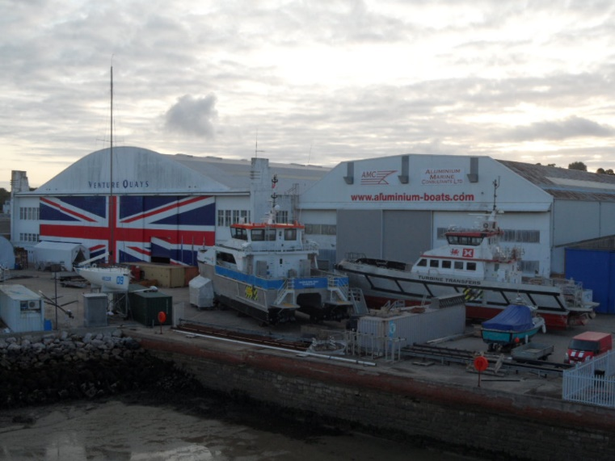
Wight Shipyard boss buys stake in AMC
Peter Morton of Wight Shipyard Co Ltd has bought a stake in Aluminium Marine Consultants (AMC) and takes his place on the board, securing the IOW boat build business well into the future.
Commercial Director Mr Rob Stewart said: “We are looking forward to working together having been neighbours for some time. With a healthy order book, the future for AMC, the Isle of Wight and UK boat building looks very positive indeed.”
He added that AMC will remain separate and continue to trade under the same name but will benefit from Wight Shipyards Co Ltd’s experience, backing and support going forward.
Peter Morton added: “AMC has such a strong reputation in the industry. By combining forces, we feel that we are better placed to monopolise aluminium boatbuilding in Europe.”
Wight Shipyard Co (WSC) is one of Europe's leading high-speed craft and aluminium builders. It specialises in High Speed Ferries, while its sister company Southampton Marine Services (SMS) provides yacht construction and restoration services.
In 2016, WSC delivered a new 40-metre high speed passenger ferry for Red Funnel. Operating the Isle of Wight services between Southampton and Cowes, this was the first fast ferry to be built in Britain in 16 years.
AMC meanwhile is renowned for building many aluminium working vessels, specialising in Wind Farm Support Craft and Crew Transfer Vessels such as the ground-breaking Turbine Transfer’s Trearddur Bay, Cwind’s first order for 4 aluminium CTV and the very latest, Mainprize Offshore’s MO4. Having achieved the 9001:2015, Quality Management System (QMS) standard and 14001:2015 Environmental Management System (EMS) standard, as well as recertification for the OHSAS 18001 Occupational Health and Safety Management Certification. <ENDS>
Notes for Editors
About Aluminium Marine Consultants
Aluminium Marine Consultants is one of the leading Aluminium Boat Builders based in the UK, specialising in the construction of aluminium OSV, Workboat and Hovercraft. Having built over 40 vessels with a team of qualified Tradesmen. With a skilled team that can be mobilised for Emergency repair services.
www.aluminium-boats.com

For more information contact:
Rob Stewart,
Aluminium Marine Consultants,
Suite E (South), Venture Quays, Castle Street, East Cowes, Isle of Wight, PO32 6EZ England.
T: +44 (0) 1983 298736
E: rob@aluminium-boats.com
www.aluminium-boats.com

For more press information and images, please contact:
Sue Stevens
Sue Stevens Media Ltd
E: suestevens@suestevensmedia.co.uk
www.suestevensmedia.co.uk
T: +44 (0) 23 8029 2992
M: 07766 163663

