May 24, 2017
For Immediate Release


Alencon Systems Gains Canadian and European Certification for SPOT Family of PV Optimizers
Product safety certification shows proof of compliance to both Canadian and European safety standards

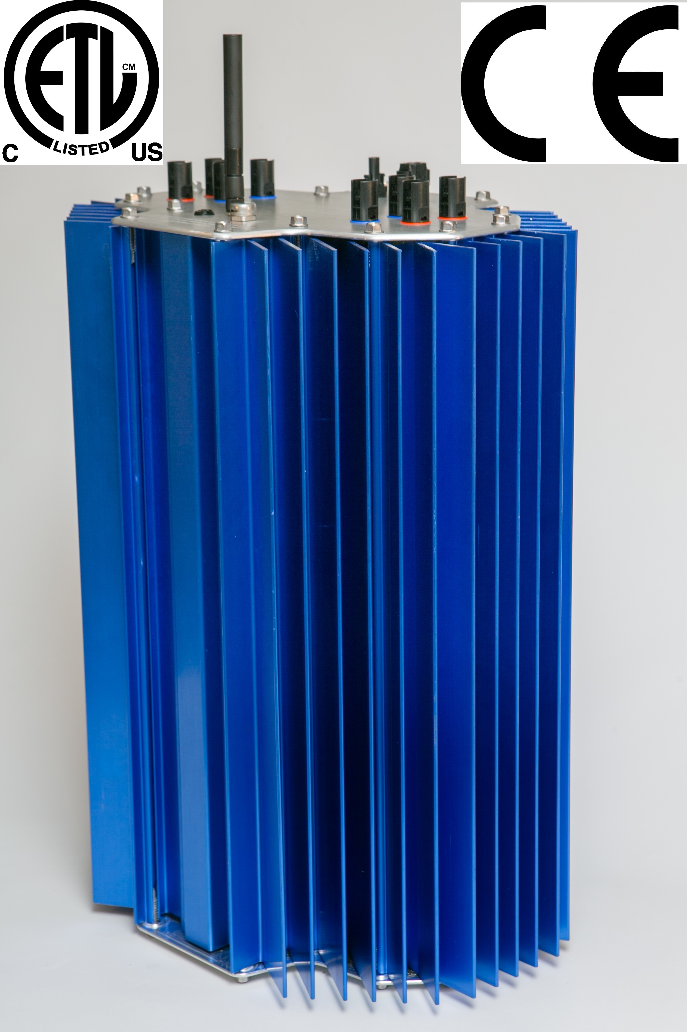
Figure 1: Alencon Systems has successfully gained ETL certification for the applicable Canadian and European safety standards for its SPOT family of products.

Hatboro, PA – Alencon Systems LLC today announced that it has successfully gained Canadian and European certification for its newest SPOT – String Power Optimizer and Transmitter – family of products. The ETL Mark from Intertek certifies that samples of the product have been tested by an independent laboratory and meet the requirements of the applicable product safety standard. The new SPOT family of products meets the requirements of IEC 62109-1, the European Union’s safety standard for the safety of power converters for use in photovoltaic power systems. Additionally, the SPOT family of products has been certified to meet the requirements of CSA C22.2#107.1, Canada’s safety standard for power conversion equipment.

The SPOT is one of the largest ETL listed DC-DC optimizer for PV applications available on the market today and is now available for installation in every major PV market in the world.
The latest version of the SPOT features a more rugged, low profile design along with a number of unique power electronics features to allow both new and existing PV plants to generate more energy while also streamlining their operations and maintenance (O&M) activities. Alencon’s SPOT can improve the yield of PV plants from anywhere 5 – 10% on average.
“Europe and Canada clearly major represent major commercial opportunities for the SPOT,” says Alencon Systems’ President Hanan Fishman. “Europe is a particularly exciting market for the SPOT as it has almost four times the amount of installed PV as the U.S. and the installed fleet is much older than the one found in the U.S.”
“Generally speaking, the older a PV plant is, the greater the SPOT can improve its performance in terms of increased yield, improved safety and decreased on-going O&M costs,” states Fishman.

Galvanic Isolation: Alencon’s Unique Solution for Better PV Plant Performance
Alencon’s SPOT provides complete galvanic isolation between PV strings and the inverter. This unique feature makes the SPOT an incredible tool for O&M because any arc or ground faults that occur with a PV string can be isolated from the rest of the solar system. Additionally, arc and ground faults can be quickly traced to the exact PV string where they are occurring which means maintenance can be more efficiently deployed and repairs can be safely done on one string while the rest of the PV plant continues to produce power.

Voltage Step-Up: Lower Conduction Losses, Better Inverter Performance
Alencon’s SPOT allows for a broad range of both input and output voltages, so it can be deployed to improve the performance of any PV plant, irrespective of its age. By stepping up voltage on the output, the SPOT is able to markedly reduce conduction losses. Additionally, by feeding a central inverter fixed voltage, the SPOT will allow a central inverter to run much more efficiently by providing it the level of voltage that allows it to perform at its highest rated efficiency.

The PV-IoT™ for Performance Monitoring and Control
In addition to providing a number of energy production enhancing features such as granular MPPT, galvanic isolation and voltage step up, the SPOT is also a very unique PV plant performance monitoring tool. The SPOT offers continuous, wireless communication to a central aggregator, so the performance of a PV plant can be studied down to the string level. The SPOT is an Internet-of-Things (IoT) ready device. By applying the PV-IoT, the Photovoltaic Internet of Things, the SPOT allows PV plant owners to assure their assets are operating at peak performance.

About Alencon
Alencon’s solutions for ALternative ENergy CONversion provide high modularity and scalability for systems from several megawatts to several-hundred megawatts. By helping to dramatically reduce balance of system costs, and increase power production through new inverter and energy harvesting technology, Alencon helps advance the state of the art and increase the financial viability of solar power. Headquartered in Hatboro, Pennsylvania, has been building PV power conversion hardware since 2009, drawing on the combined decades of power electronics experience of its engineering team.

About Intertek
Total Quality. Assured.
Intertek is a leading Total Quality Assurance provider to industries worldwide. Our network of more than 1,000 laboratories and offices and over 42,000 people in more than 100 countries, delivers innovative and bespoke Assurance, Testing, Inspection and Certification solutions for our customers’ operations and supply chains. Intertek Total Quality Assurance expertise, delivered consistently with precision, pace and passion, enabling our customers to power ahead safely.
intertek.com

Press Contacts:
Alencon Systems Contact:
Hanan Fishman
President, Alencon Systems

Phone: (484) 436-0035 ext. 103
hfishman@alenconsystems.com

Intertek Contact:
Cheryl Prejsnar
Public Relations Manager
+1 630-481-3185
cheryl.prejsnar@intertek.com

Included pictures: alencon_ce_csa_certification.jpg

