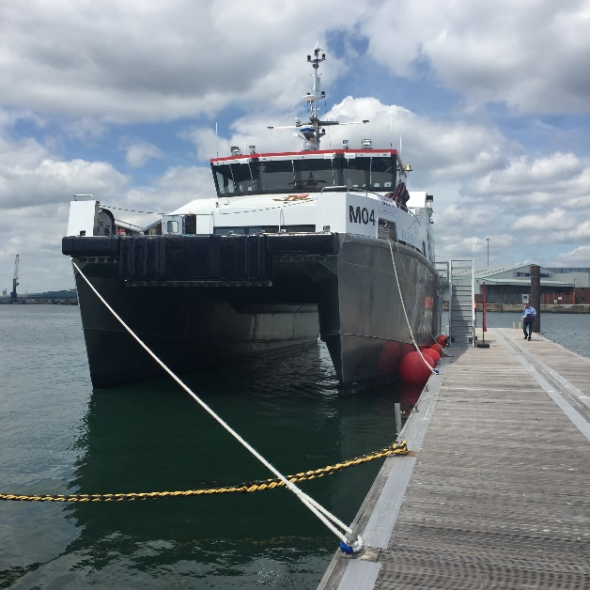
1000 days free from LTI-Lost Time Incidents - £1000 for Grimsby & Cleethorpes Sea Cadet Unit I

Mainprize Offshore Ltd has achieved 1000 vessel days free of LTI (lost time incident) while providing services for end client Dong Energy.
Mainprize Offshore Ltd are providing guard vessels direct to Dong Energy and indirect through their sub-contractors. LTI is one of many key point indicators that companies use to determine and analyze a company’s performance.
“The 1000 vessel day milestone also equates to over 60,000 person hours and is testament to the management and crews of the vessels and the support given by the Dong Energy teams and I would like to thank everyone involved in Mainprize offshore success in achieving this milestone.” Bob Mainprize
The purpose of the guard vessel is to ensure the safety of all persons in and around the site and to protect the assets of Dong Energy, this involves notifying vessels of the safety zone and any updates on vessel movements, restrictions etc. This is usually undertaken by the guard vessel transmitting security messages on marine radio channels at intervals determined by the level of vessel traffic, it is also to contact vessels and advise of the safety zones and updates.
Mainprize Offshore Ltd have been operating on the Westernmost Rough and Race Bank offshore wind farms for some years. Mr Bob Mainprize of Mainprize Offshore Ltd commented that the high Health, Safety and Welfare standards that Dong Energy insists on is welcomed by Mainprize Offshore Ltd. “We pride ourselves in promoting the best practices and providing our clients with the best quality and safest possible service. We have therefore decided to award £1,000 to the Grimsby sea cadets, Grimsby sea cadets were chosen due to the marine nature and location of the Dong Energy hub in Grimsby. This I feel is a hand in glove approach that will benefit the local community and support the early training and development of the younger generation.”
On behalf of the Grimsby & Cleethorpes Sea Cadet Unit I would like to congratulate Mainprize Offshore on receiving this award and express our heartfelt thanks and gratitude for this generous donation.
The achievements of Mainprize Offshore limited in receiving this award will serve as an inspiration to our cadets and an example of what a career in the maritime sector can lead to.
Our unit currently has 56 cadets involved in marine training and engineering many of whom will hopefully gain employment in the maritime sector of which the renewable industry and DONG Energy in particular has grown rapidly in our area and have become very valued community partners.
This particular donation will go towards a major refurbishment of the unit due to start very shortly which will allow us to further increase our cadet numbers.

Notes for editors

About Mainprize Offshore Limited
This family company was formed in 1979 and has operated in the North Sea for over thirty years. During this time the company has gained extensive experience in the offshore oil, gas and renewable industry. Its main areas of operations are support work including cables - pipeline guard, chase work, pre lay grapnel operations, grab sampling and camera work, seabed surveys, impact surveys, traffic monitoring and TV work.

For more information contact:
Bob Mainprize,
Mainprize Offshore Limited,
Unit 15 Manor Court,
Manor Garth,
Eastfield,
Scarborough,
North Yorkshire,
YO11 3TU,
UK
T: +44 (0)1723 586022
E: info@mainprizeoffshore.co.uk
www.mainprizeoffshore.co.uk

